Ringwood Day Nursery
New Year News

Merry Christmas and a Happy New Year!
We would like to take this opportunity to wish you all a most fabulous festive season filled with the most fun and fabulous food!

Great news about our referral reward...
Congratulations to the first of our customers to receive their reward for referring a new customer to us, their January bill has been reduced by £100.00

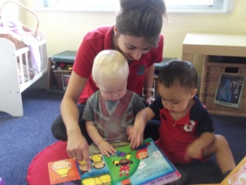
Spread the Word about Stay and Play in the New Year
We are opening our doors for a new free session for anyone wanting to see how great our nursery is for all ages of children, this is the ideal opportunity for parents to find out more about us and have some fun with their children at the same time. The sessions will run from 2 till 3 pm on Thursdays from 15th January to 5th February. All are welcome but booking is essential, please ring 01425 470709 Sue, Jenni or Sheila to reserve a place.
Please share this with your friends, work colleagues, relatives or anyone who is interested in finding out about our day nursery. This could lead to you too enjoying our referral reward when they give your name when they join us. Keep referring!

New Year refurbishment
Continuing the refurbishment programme that began this year with a complete redecorate, we recently had some new roofing over the playground porch and guttering near the baby room.
Over the Christmas closure period our vinyl floor in the cloakroom, Pear room and Woodpecker room is being replaced with a new blue vinyl... yippee!

A quick reminder...
From January 2015 please remember we will no longer be able to accept payments made via cheque or cash.
Payments can be made via BACS and our bank details are given on each month’s invoices.

Hip, hip, hooray! Food Hygiene – a full house!
Well done to our chef, Leigh, who lead us to achieve a level 5 rating for our Food Hygiene practices. The Environmental Health Officer wrote in his report, “No issues noted during this inspection. Well done.”
We join our Bournemouth setting, Redhill Day Nursery and our Verwood setting, Verwood Day Nursery, in achieveing the highest rating of 5 stars this year. Plus the children say our food tastes good too!

A sad farewell and a warm welcome...
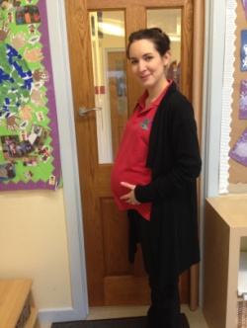
As some of you may already know, our lovely Sharon will be leaving us on 24th December to start her maternity leave. We all wish her well with the new arrival and she will be greatly missed by both staff, children and parents alike.
A warm welcome to Jo, our newest member of staff. Jo joins the fabulous Pear room team and as well as being a qualified Nursery Nurse, she is also a fantastic mum, a job role that many of you can relate to! We all look forward to having her in the room.
New!
We have ordered brand new all weather suits for the children which should be arriving very soon. We expect to be enjoying the Winter weather in the New Year!

Paediatric First Aid opportunity
In February we will be hosting a two day full Paediatric First Aid course. Our staff will be renewing their qualifications and we wanted to offer the opportunity to you to gain this important knowledge too. If you are interested please contact Sue or Jenni for more details. The cost for the two days is £40 per person.

THANK YOU!
A massive thank you to all who supported out Christmas events. The activity afternoons and the Wriggly Nativity performaces were great fun for us and I hope you enjoyed them too.
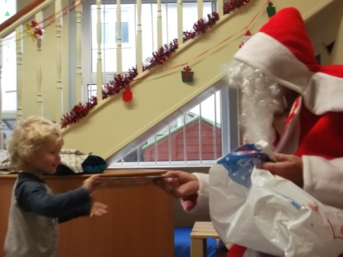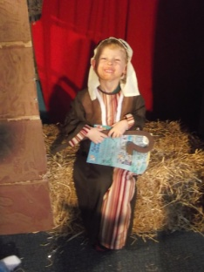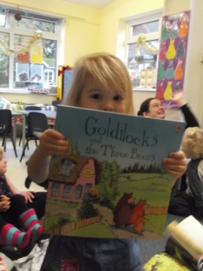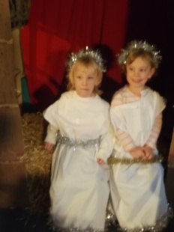

Christmas closure dates
For children attending for funded sessions only, the last day of term will be Friday 19th December.
The nursery will close on Wednesday 24th December, reopening on Friday 2nd January 2015.
Funded sessions begin again the week commencing Monday 5th January 2015.
Events for 2015
We are planning a busy year in 2015, it is going to be fun and full on!
January – Stay and play sessions starting 15th January
February – First Aid training
March – World Book Day then Easter!
April/May – Nursery photographer and parent’s evenings
August – Leaver’s party (school leavers)
October – Pumpkin week and parent’s evenings
November – Children in Need
December – Christmas activities

From all of us at Ringwood Day Nursery...
Merry Christmas and a Happy 2015!
We hope all of you have a wonderful Christmas and we look forward to seeing you and your children in the new year

